BRISTOL ROYAL INFIRMARY EMERGENCY DEPARTMENT
Global Health Fellowship
Deployment Guide for Clinical Fellows
Dr Andy Lockyer
andy.lockyer@uhbw.nhs.uk

Bristol Royal Infirmary Emergency Department
Global Health Fellowship

Dr Andy Lockyer (andy.lockyer@uhbristol.nhs.uk)

Structure of Post
This is a Health Partnership established between the BRI ED, other regional ED’s & Nanyuki ED in Laikipia district, Kenya. There has been a longstanding relationship between the South West UK and Laikipia district under the umbrella of Future Health Africa and in particular involving Torbay hospital and Nanyuki and Nyahururu hospitals. This work has been largely focussed on primary care, orthopaedics and Quality improvement, and there is now a wish to develop Emergency Care.

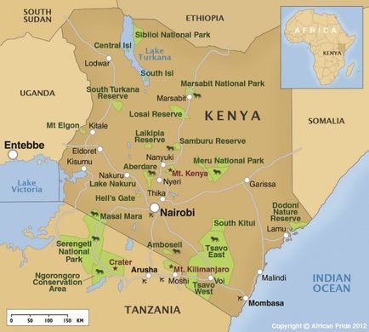

Nanyuki
Nanyuki is a busy and rapidly growing town on the equator, a 3 hour drive north of Nairobi in the foothills of Mount Kenya. It is a popular base for tourism and there is a significant local military training presence with the British Army Training Unit on the edge of town. It means a thriving and active main street with most amenities available readily. Given it’s altitude at approximately 2000m above sea level, it has a pleasant cool climate with consistent temperatures around 20-25 degrees C.

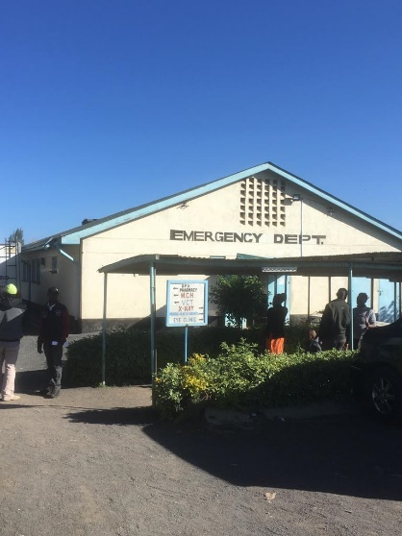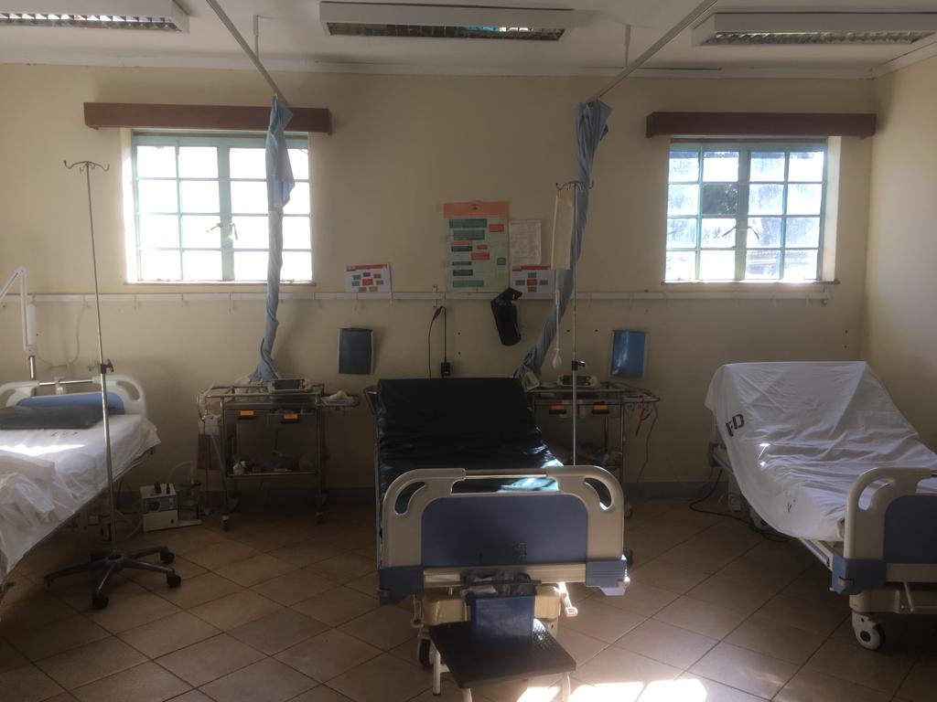
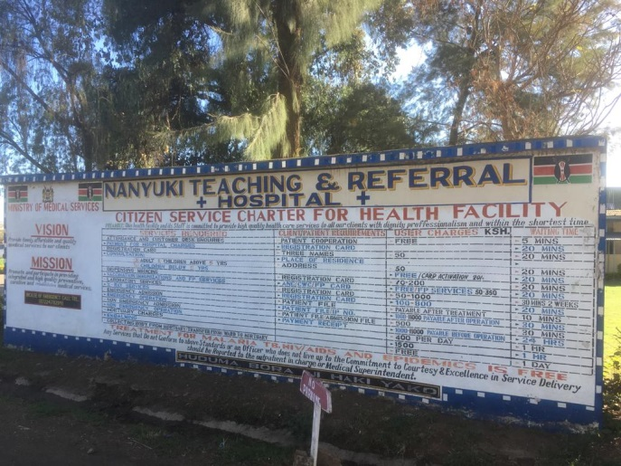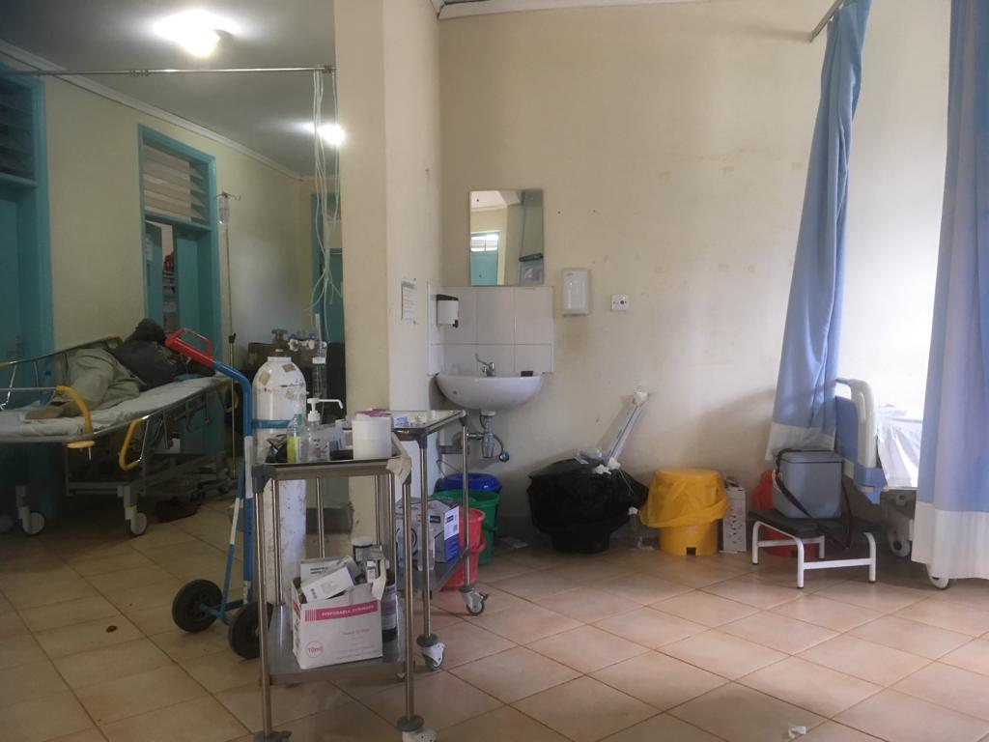

This is intended as a “quick reference” guide to support the process of planning your deployment and assisting in the early stages of your time in Nanyuki.

Personal Health/Wellbeing
Our primary concern is your safety and wellbeing while on deployment. You remain supported by BRI occupational health, but we will support you directly with any issues that may arise. We also work alongside “Future Health Africa” and they have formal guidance and support available in the volunteer guide on their website at www.futurehealthafrica.org. There is a list of suggested immunisations we would recommend in addition to your routine NHS immunisations for health care workers.
Suggested: Hepatitis A, Typhoid Optional: Rabies, Yellow Fever
The area is “low risk” for malaria but not “no risk” so you may decide to take malarial prophylaxis.
There is no requirement to inform your supervisor of any pre-existing medical problems, but you are invited to share any information you think may allow your supervisor to better support you during your deployment. You are also welcome to discuss any potential issues with personal medical supplies required.
Future Health Africa provide SOPs for occupational exposure incidents in a healthcare environment, and we have access to “Post exposure prophylaxis” for any potential HIV exposure incident.
We would recommend having a personal travel insurance policy that covers you for expected tourism activities such as hiking.
Most areas such as cafes, malls, hotels etc will have some form of security. Remember to take caution in public areas with valuables, and that while there are many ex-pats and tourists around Nanyuki, you may be seen as a target for crime.
We would recommend you complete the new BSAFE module, available online.
https://trip.dss.un.org/dssweb/bsafe.aspx
Visas
We recommend that you obtain an e-visa as a “tourist” visitor to Kenya as you will not be registering as a practicing health profession. This is available on arrival in Kenya , or at http://evisa.go.ke/evisa.html in advance of travel
Flights
Skyscanner is fairly reliable for comparing the major airlines, and may take you to a 3rd party travel agent. Direct flights are mainly through Kenya airways and BA, although numerous airlines provide reasonable single stop routes (eg Etihad, Air France, KLM) and KLM will allow you to fly from Bristol via Amsterdam. You would expect to pay £350-500 for a return flight.
Airport Transfers
This can be arranged through Stephen on +254 722 942974. He will collect you directly from the airport for the 3 hour journey north to Nairobi. He has an excellent reputation and long history of service to our partner organisations. He charges approx. £80-100 in total for this journey.

Currency:
The Kenyan shilling is the local currency and the exchange rate is approximately 145 KSh: £1. It would be best to order some KSh either online or pre-order for airport collection, although there are cashpoints available in multiple locations in Nanyuki.
Some tourist activities and lodges may prefer US Dollars for payment, but will normally accept KSh.
Some goods are available at very cheap local prices, but Nanyuki now has more western style cafes and a new mall which would charge prices closer to those you would be used to in the UK.

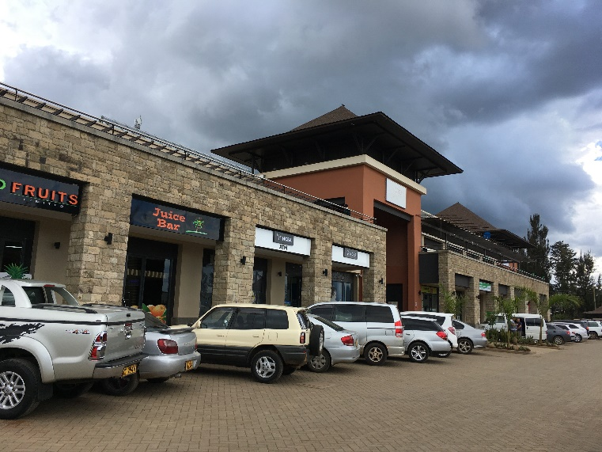

Accommodation:
Nanyuki has a variety of accommodation available, and you may decide where to stay depending on your own budget and preference. We would suggest you arrange comfortable lodge accommodation for at least the first couple of nights to allow you to settle in and arrive, and we can recommend secure and reliable options. However, it is popular with volunteers staying for longer periods, to consider “Homestay” accommodation with reliable locals who offer rooms to visitors.
Simba Lodge: Basic but secure 2 star hotel about half a mile north of the hospital. Reasonable facilities with a basic bar/restaurant on site, and a basic outdoor social area. Others have felt that as the bar is not lively, it would potentially feel quiet and isolated here for a longer term stay. Approx £20pn for twin room.

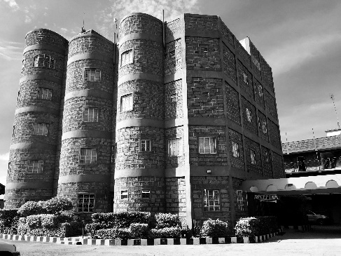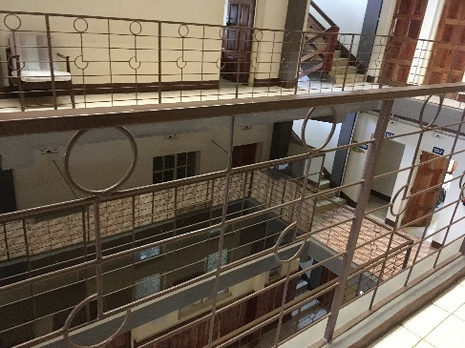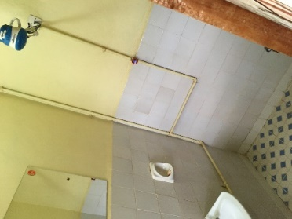

Nanyuki Country Club: A short distance from the main road in a similar area to Simba’s, this Country Club is reasonably luxurious. Either traditional rooms are available or luxury huts are another option. There are beautiful grounds with golf course, swimming pool and bar/restaurant. Approx £40pn for twin room, £35pn for single room (We have developed an agreement with NCC to discuss longer stay rates so please speak with recent clinical fellows)
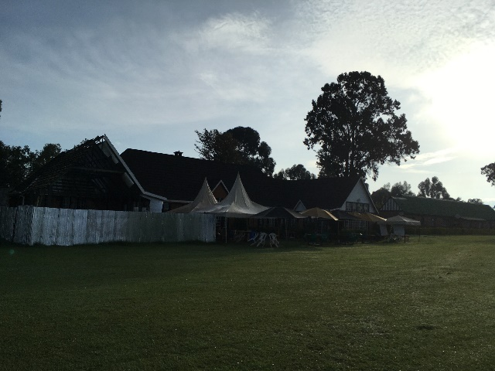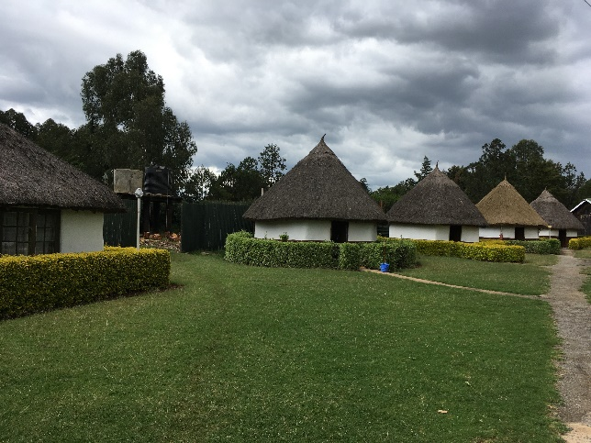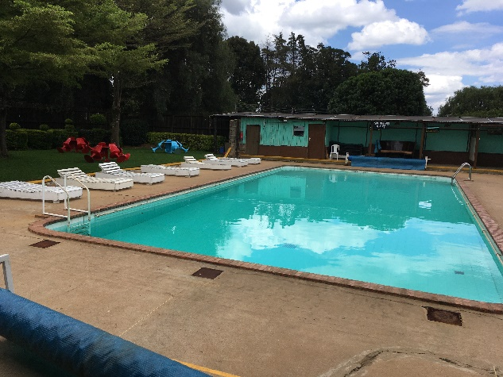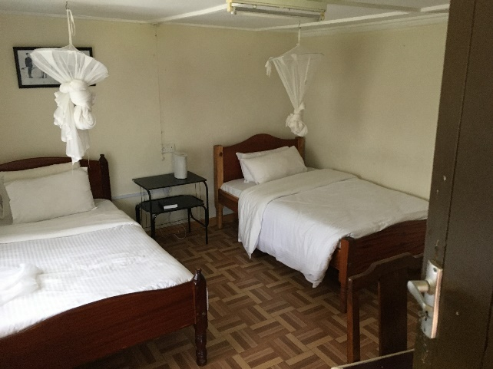

Homestay Options:
1.About 1 mile South of the hospital, Naomi Kimani has a home she shares with her 2 daughters and nanny. It is on a secure estate, and while it has a basic looking entrance gate, is clean, tidy and safe with reasonable living space and a garden. There are dogs at the property. It is a 20 minute walk to the hospital. She charges £8pppn for board with all meals, including making packed lunches. She also invites guests to join in with family activities and celebrations as they wish. Naomikimani292@gmail.com
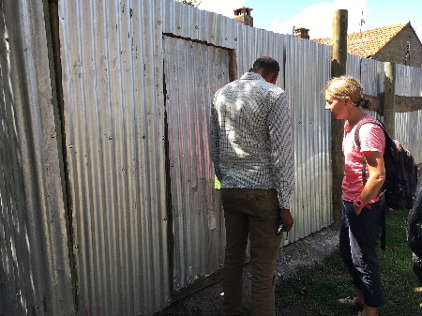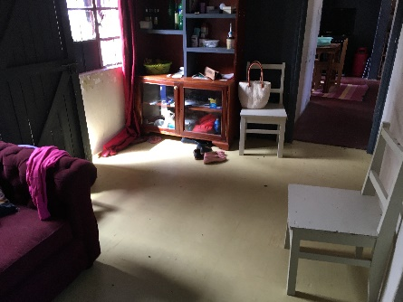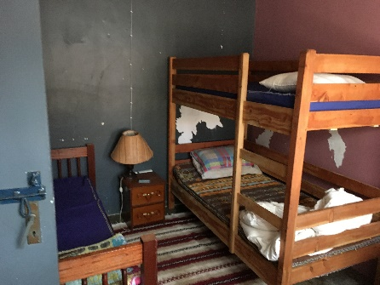
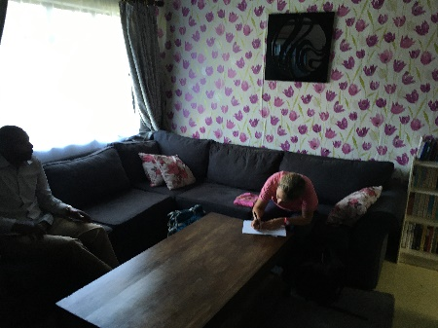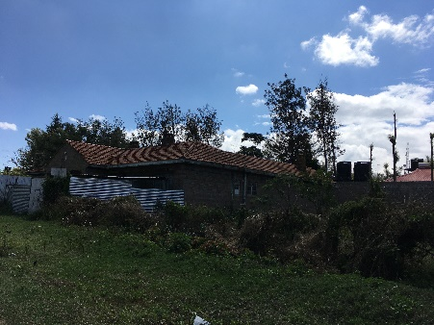
2. Around 1.5miles from the hospital, this higher end accommodation is available where Josephine rents multiple rooms in a property on a gated and secure estate. She often takes in a variety of overseas volunteers. The property has cats. She charges £16pppn including all meals and self-made packed lunch. The walk is likely 30 mins to the hospital and town, although she reports some volunteers arrange daily taxis. Njosephine74@yahoo.com
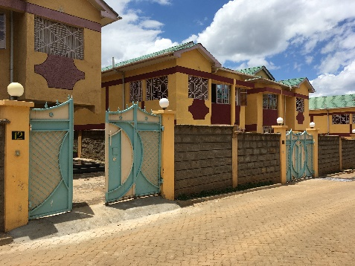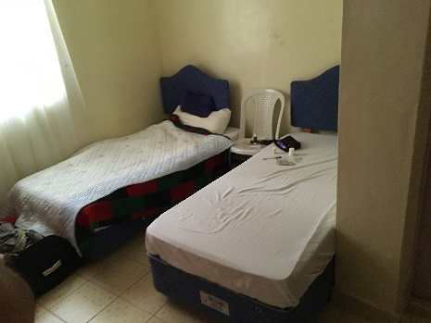
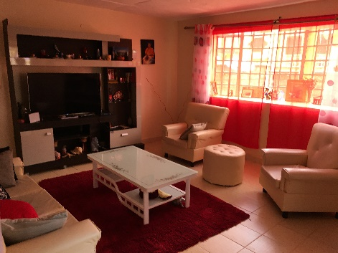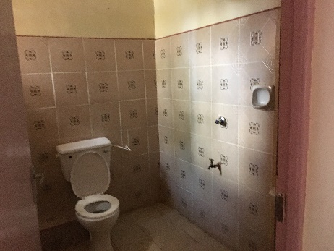
Transport
Once in Nanyuki, there are various options for getting around the town. While we would recommend that you avoid walking around town after dark, it is largely considered safe during the daylight hours, and most things are within walking distance of the hospital and town.
It would be reasonable to consider bicycle transport, being aware that the roads are hazardous by UK standards, and you would need to travel with caution. If you are interested in this, we could consider supporting the purchase of bikes to remain in Nanyuki. Taxis and group taxi buses are an option, and we would suggest arranging taxis through either your accommodation, cafes/restaurants or Martin Macharia on +254 725320875 (deluxetravelsolution@gmail.com). We wouldn’t recommend taking a motorcycle taxi as the accident rate is high. You will likely find that with activities further afield and in the national park area, it is possible to arrange transport as part of an activity package. Stephen (airport transfers) is also a reliable contact if you wish to independently source transport options further afield and towards Nairobi.

Communications
Wifi is readily available in most hotels, bars and restaurants. Services are generally good enough to support Videocalls and reasonable downloads.
It is possible to buy a Kenyan SIM card and there are good data and call packages available from around £10/month. There is a Safaricom office at the old mall on your left between the equator and town centre. It is challenging to have a Kenyan SIM placed in a contract phone from the UK without it being unlocked, so we will aim to provide 1-2 phones that can be used by yourself and subsequent clinical fellows for local use.

Cafes/Restaurant
There are some really excellent quality places for some R&R, ranging from old colonial-style grandeur to really modern cafes. Some that we would recommend as safe options would be:
Le Rustique: Lovely restaurant/café with nice rear garden just out of town, offering peaceful retreat and excellent quality food and bar. Meals range from £5-10 and Beer £2-3.
Nanyuki Country Club: Wonderful grounds and old fashioned bar area, pool and sports activities. Food not of such high quality, but perhaps a more social and lively evening spot.
Mall: At the start of the hospital road from the main road, this modern mall offers a supermarket to rival anything in the UK, and modern café, juice bar and restaurant.
Dormans: Nice café on the main street
Shack Café: Another nice coffee and snack spot opposite Dormans
However inviting, we would advise against drinking in informal local bars for safety reasons.

Recreation:
The Country Club is a potentially good option for running, as you can complete an approxx. 2 mile circuit of the golf course. Swimming pool is available. People have had different responses there in terms of being allowed access. You don’t seem to need membership to access the general area, but this may be needed for regular swimming.
African Ascents are a trekking and adventure company run by a local contact, Julian Wright, who is married to an EM doctor, and would be happy to help arrange any activities for you on Mt Kenya and the surrounding region. www.africanascents.com

Donations
While this a mutually collaborative project and we are not looking currently to donate equipment to the hospital, some informal donations have historically been received well. Biscuits are always popular for local staff, and childrens toys/clothes/colouring pencils can be useful for the paediatric wards.

Clinical Care
You are expected to take on a support and development role alongside the emergency department team, and not aim to undertake routine clinical care indepdently. We recognise that in certain emergency situations, you may have a professional obligation to support clinical care, so supporting clinical care is reasonable as long as this is supervised by a Kenyan registered medical practitioner.

Code of Conduct
There is a Future Health Africa code of conduct for volunteers which you will be expected to sign. Please also remember you are representing the BRI Emergency Department at all times, and the future of the program relies on the professional behaviour of our visiting clinicians.
We would recommend that on your arrival at Nanyuki hospital, you attend the main management block (to your right at the main entrance, and last building on right) to introduce yourselves to Timothy Panga, the County Minister for Health.. We ask that you are respectful of the efforts made by the hospital leads and staffs in making this project work, and act with great courtesy at all times.

Framework for 8 week deployment

Week | Activity Focus | Aims/Tasks
1 | Arrival / Familiarisation | - Meet key clinical and management leads  - Establish safe accommodation  - Ensure adequate communications  - Identify issues/concerns  - Identify projects and set goals
2 | Community Project | - Gain Health system context  - Familiarise with local and national health/social issues  - Acclimatise to local culture
3 | Commence project | - Plan any audit of data capture  - Consider “process mapping” to understand patient journeys  - Clarify goals with local staff  - Consider interventions
4 | Consider Interventions | - If training visit part of core needs, establish which staff and arrange necessary rota management and physical space for training (liaison with clinical leads for this)  - Potentially introduce any new documentation
5 | Reflection and Continuation | - Continue improvement work  - Consider if need to adjust aims or activities  - Assess for second half of deployment, what end point/goal will be
6 | Training visit preparation | - Prepare learning materials  - Prepare physical training area  - Consider detail of training
7 | UK Training Visit | - Co-ordination of short training course  - Induction of UK visitors  - Supervision of training activity
8 | Conclusion | - Establish ongoing project activity and aims  - Confirm next Fellow dates and plans with local staff  - Debrief with staff  - Reflection on achievements

While observing and engaging in routine clinical practice within the ED and outpatients is required to gain context and understanding, to work with local staff towards development and improvement, we are keen that Clinical Fellows are kept busy and do not have prolonged periods feeling ineffective in an observational role. It is important that beyond the first few days of acclimatisation, goals are set for project work, and while activities may be based around the ED, it is likely Fellows will be working more broadly on projects rather than continuing to just directly observe patient care.

Training Course Options

GRASPIT
Global Recognition and Assessment of the Acutely Sick Patient and Initial Treatment
This is a MDT course with a mix of simulation and lectures, aiming to reflect the UK ALERT course. It runs over a 3 day cycle normally, as a one day course, but then aiming to offer a 2nd day of “Train the Trainers” and a 3rd day with a locally run course by these providers, to allow the course to sustain itself locally. This could be developed to give a more EM focussed approach.
This was established through previous Torbay links, and Dr Matt Halkes (matthew.halkes@nhs.net) is the Anaesthetic Consultant who leads on this. He would support it’s re-launch and Philip Longhurst (Philip.longhurst@live.co.uk) is a Peninsula trainee keen to help refresh and write scenarios.
Pros: Sustainable and efficient training course
Cons: Not traditionally ED focussed

WHO Basic Emergency Care Course
This course, developed by WHO and ICRC, can be run over 3-4 days. You can download participant packs and slides online. There is flexibility in how you run with quite standardised content.

Pros: Good training for local environment
Cons: Not locally sustainable and high requirement for staff availability

Useful Websites

www.emergencymedicinekenya.org
www.futurehealthafrica.org

Other reading
Human: Solving the Global Workforce Crisis in Healthcare (Mark Britnell)
No Picnic on Mount Kenya (Felice Benuzzi)
It’s Our Turn to Eat (Michela Wrong)

