BRISTOL ROYAL INFIRMARY EMERGENCY DEPARTMENT
Global Health Fellowship
Pre-Fellowship Information Pack

Dr Andy Lockyer
Lead BRI ED Global Health Program
andy.lockyer@uhbw.nhs.uk

C
Bristol Royal Infirmary Emergency Department
Global Health Fellowship 2021/22

Structure of Posts
A 12 month clinical fellowship with 80% time allocated to the BRI ED and 20% allocated to activity in Global EM. Normal annual/study leave allowance applies to both elements of the post .
There is flexibility around how the 20% of Global Health activity occurs. It would be likely that a single “overseas deployment” (7-8 weeks) would form a large portion of this time, with other time allowed for ongoing work related to this deployment.
There are normally 8 Global Health Fellows so a typical annual deployment calendar may look like this:
Fellow | Aug | Sept | Oct | Nov | Dec | Jan | Feb | Mar | Apr | May | Jun | Jul
A | BRI | BRI | MSc | D | D | BRI | BRI | BRI | BRI | BRI | BRI | BRI
B | BRI | BRI | MSc | D | D | BRI | BRI | BRI | BRI | BRI | BRI | BRI
C | BRI | BRI | MSc | BRI | BRI | D | D | BRI | BRI | BRI | BRI | BRI
D | BRI | BRI | MSc | BRI | BRI | D | D | BRI | BRI | BRI | BRI | BRI
E | BRI | BRI | MSc | BRI | BRI | BRI | BRI | D | D | BRI | BRI | BRI
F | BRI | BRI | MSc | BRI | BRI | BRI | BRI | D | D | BRI | BRI | BRI
G | BRI | BRI | MSc | BRI | BRI | BRI | BRI | BRI | BRI | D | D | BRI
H | BRI | BRI | MSc | BRI | BRI | BRI | BRI | BRI | BRI | D | D | BRI

The planning of the Global Health activity will be co-ordinated with Andy Lockyer, while requests relating to rotas and leave will be directed through the online system under the supervision of Jess Hutchinson (SHO rota) and Jenny Jones (MG rota). There are other planned activities:
2nd Sept 2021: Global EM Induction
We have a separate 4 hour Global EM Fellowship induction in the ED Seminar room
Sept 2021: Southwest Global EM Group meeting
Regional meeting of Global EM clinicians to discuss local activity and projects. May be an online meeting, but once able is planned for Dartmoor with a group hike alongside meeting.
Sept/Oct 2021: Global Health MSc module
University of Plymouth module for those interested in undertaking the 5-6 day Global Health MSc module. Was remote in 2020, and we will receive an update.
2-11th October 2021: BRI ED educational deployment to Nanyuki
3 members of BRI clinical team will visit to provide training in Nanyuki ED
Early November 2021: Global EM Conference
We have previously held a 1 day study day with some excellent external speakers. There would be an opportunity to broaden this to a small scale conference event this year.
Bristol Nanyuki Emergency Care Project
This is the Health Partnership established between the BRI ED & Nanyuki ED in Laikipia district, Kenya, alongside Future Health Africa.
Recent projects: Triage, patient flow, nursing skills

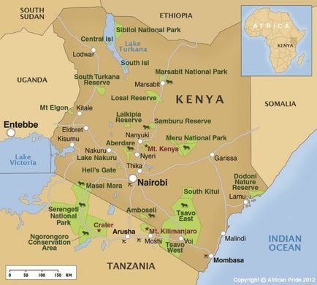

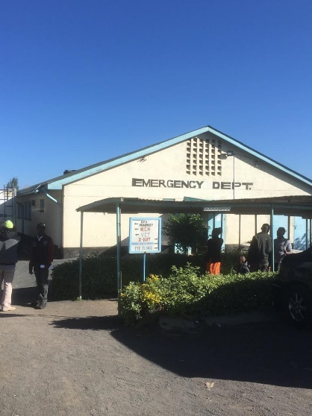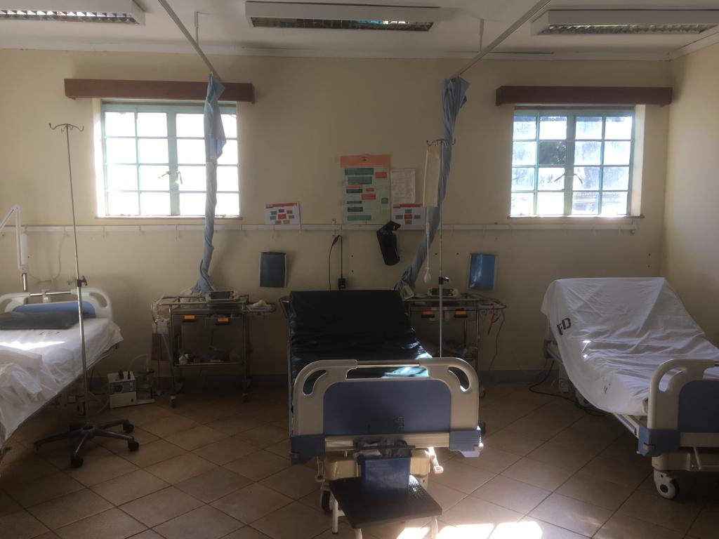

This project aims to support the development of emergency care in the Nanyuki Emergency Department through several key processes:
- Emergency Medicine Clinical Fellow placements in Nanyuki
- Deployment of Volunteer BRI ED staff for the provision of training in Nanyuki
- Potential longer term posts for visiting UK ED staff & reciprocal visits for Nanyuki staff

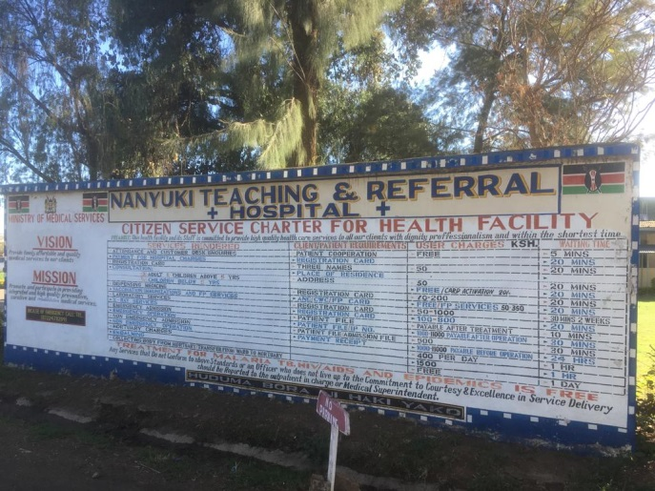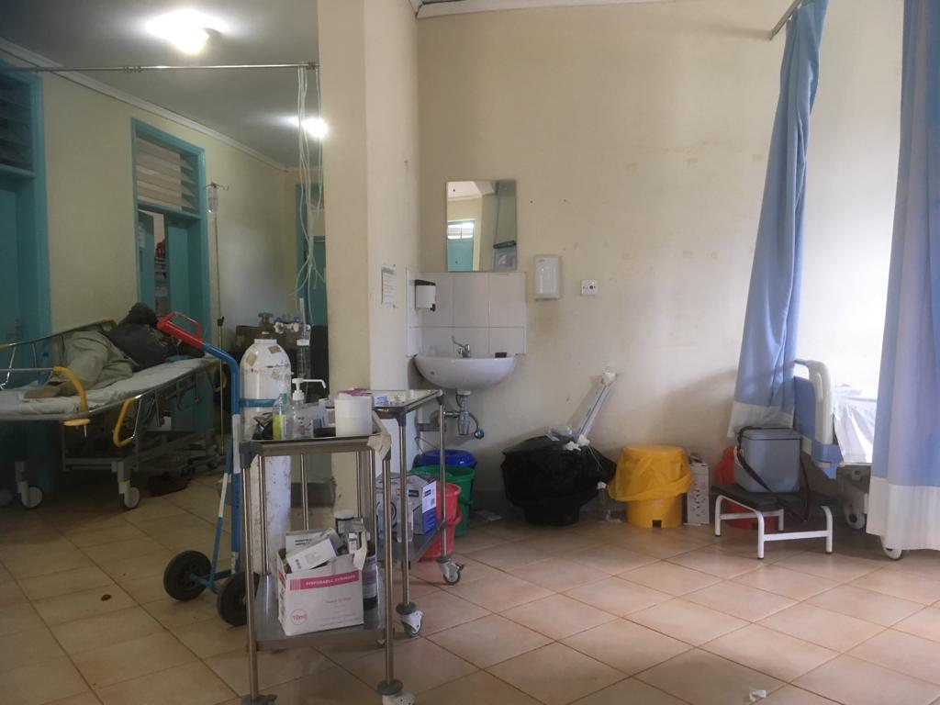

Clinical Fellow Deployment to Kenya

- As the project lead, Andy Lockyer will guide you through the fellowship to ensure you know upcoming activities, expected travel dates and assist you with your preparation to deploy

- A clinical fellow will travel to Kenya under the governance structure of the program and FHA with 24 hour availability of UK based senior support

- Locally, they will work under the supervision of the clinical lead for the Emergency Department and Hospital CEO.

- Risk assessments have been conducted in preparation for the deployment, but these recognise that not all risks can be entirely reduced in work of this nature. We would aim, where possible, to deploy 2 clinical fellows simultaneously to improve safety and security

- The project will assist in the arranging of accommodation locally in Kenya, likely initially in Guest House accommodation and then subsequently the possibility of private accommodation.

- There are excellent travel possibilities in the region and the clinical fellow would be encouraged to engage in exploring the region as much as possible. We would support a clinical fellow to ensure they have adequate preparation for safe travel (eg immunisations)

- We will normally contact pairs/individuals around 3-4 months before deployment with a full Deployment Guide so they can start making their own arrangements. Before deployment, you will be required to sign a volunteer agreement with Future Health Africa, including a code of conduct

Post Graduate Opportunities
We work closely with the University of Plymouth, and one of the key partners in the project is Dr Lucy Obolensky, who is the program lead for the Global & Remote Healthcare MSc there.
The MSc has a 5-6 day Global Health module, normally in Sept/Oct. There is historically a £500 fellowship study leave bursary fund from UHBW, and we have achieved a separate £300 uplift funding for each Global EM fellow. This can significantly subsidise the Global Health module, which would include postgraduate credits and an excellent introduction to Global Health theory with networking opportunities.

BRI Global Health Projects
We have ongoing projects that you can get involved in taking forwards, and are happy to discuss your own ideas we can support
- Paediatric Blast Injury Manual Project
- RCEM Reciprocal Leadership Fellowships for African Trainees
- Patchworking against Poverty (Leo Nakhimoff)
- “Team Talk” – community health education projects alongside FHA (Lucy Obolensky)

UK Based Training Activity
This is flexible but there are some proposed ideas for how a clinical fellow might develop their Global Health experience while in the UK working in the BRI ED
- Organising Local Training Day/Conference based in Bristol
- Completion of UN and WHO online learning, including “Security in the Field I&II” training pre-deployment
- Conference poster presentation summarising work
- Publication RCEM learning global health module
- UK-Med pre-deployment training

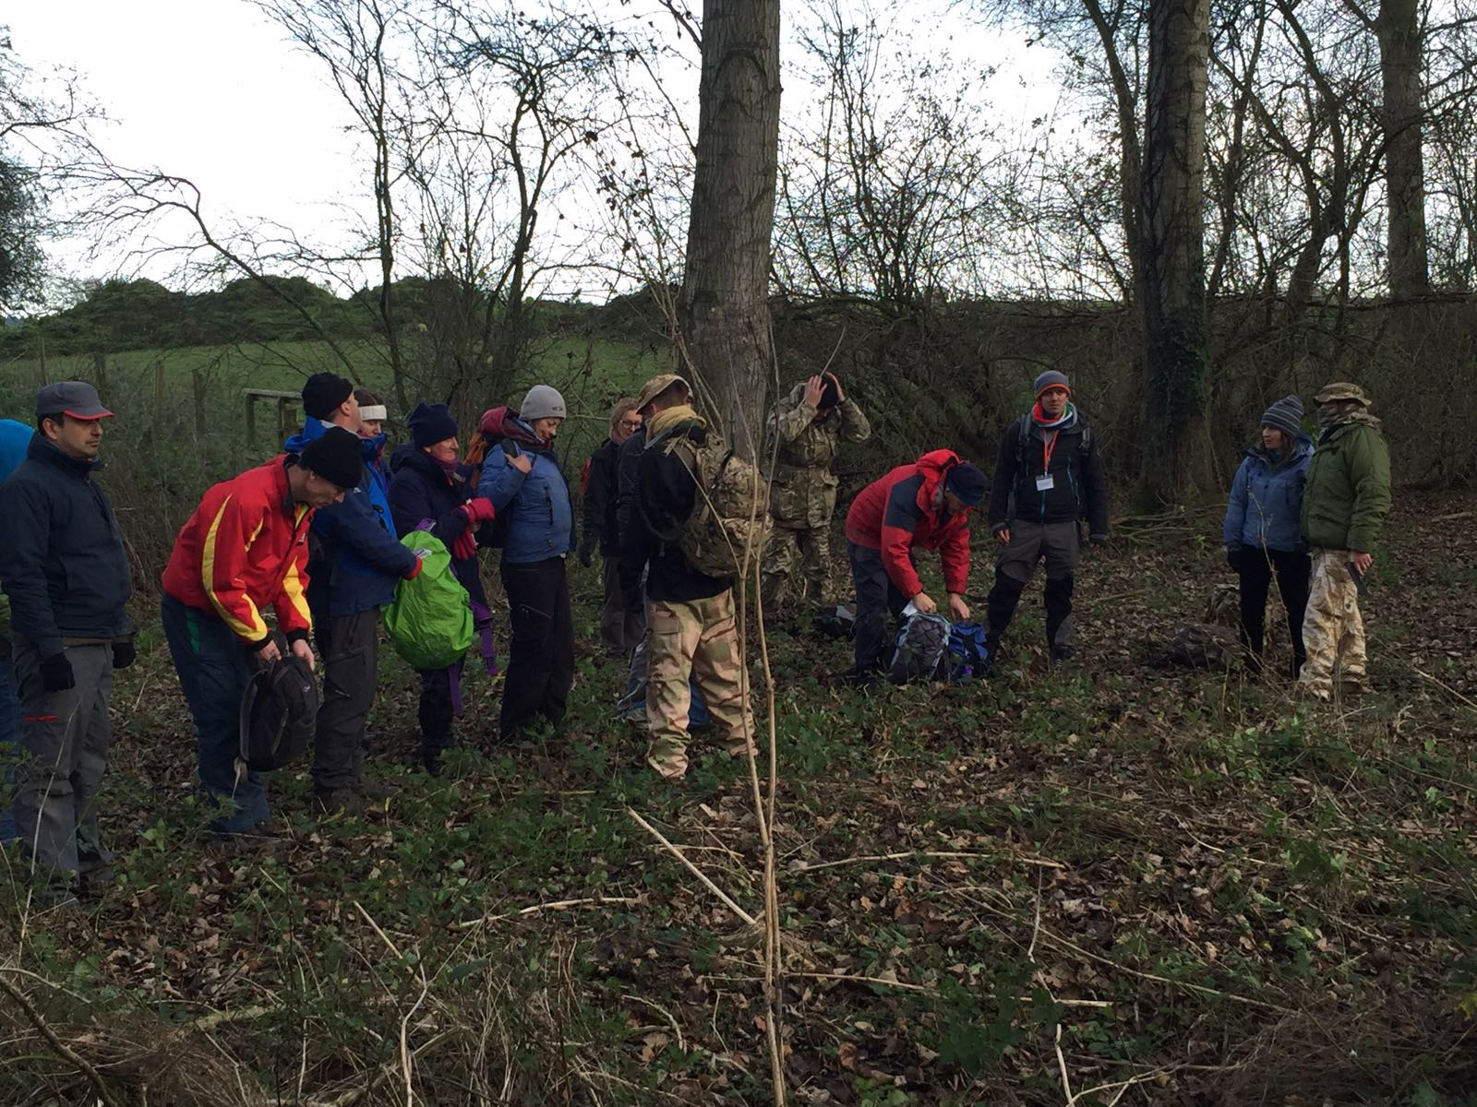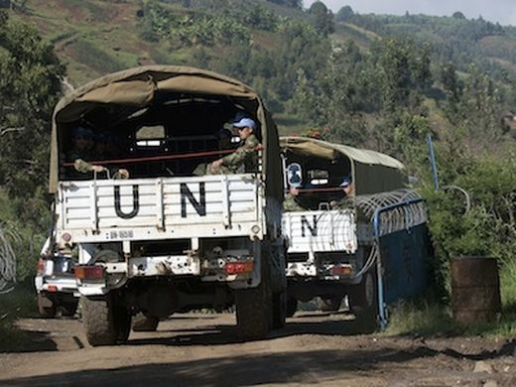

Finance
There is a project fund that has been established with the aim of being able to financially support permanent BRI staff for teaching deployments alongside the clinical fellows, mainly through charitable donations, fundraising and university activities. If our fundraising continues to improve, I am hopeful to commence small grants to clinical fellows to support their personal costs on deployment.
As it stands, we do ask that Fellows cover their basic costs of deployment, but should let us know of any major issue. We recognise that many Clinical Fellows will have fixed ongoing costs in the UK, but historically it has worked that experiencing a lower cost of living while in Kenya while receiving 2 months UK wage has meant that fellows have found themselves able to manage this arrangement.
Prediction for 2020/21 Clinical Fellow Costs would be:
Flight: £350-400
Accom: £150-200
Visa: £40
TOTAL: approx. £600
Next Steps ………..

- Deployment Dates: Please let me know in advance if you have a preferred deployment time period or any major restrictions on timings. We can then have a proposed timetable in time for induction.
- GH Module: Please let me know if you would be interested in undertaking the Global Health MSc module, either as stand alone CPD or towards a postgraduate qualification
- Personal Issues/Health: You are welcome to discuss any personal concerns that may affect your post and deployment confidentially with Occupational Health, but given the unique nature of the overseas deployment, I am also happy to discuss any specific issues that may help us support your safety and wellbeing when in Nanyuki. You can speak with Rebecca Thorpe as clinical lead as an alternative.
- Projects: If anyone has a current project or wishes to engage prior to starting your post, I am always happy to be contacted, if it means your fellowship will be more productive.

